# Source Code Management

**Course Code: CSE 2015 Slot: L3-L4**



**Name: Varun**

**SEN No.: A86605224316**

**Faculty: Dr Monit Kapoor**

## INDEX

|  |  |  |
| --- | --- | --- |
| **S. No.** | **Lab Session Title** | **Page No.** |
| **1** | **Git Fundamentals** | **3** |
| **2** | **Installing Git on Windows** | **4** |
| **3** | **Basic CLI Commands** | **5** |
| **4** | **Vim Text Editor** | **8** |
| **5** | **Git Commands** | **10** |
| **6** | **SCM Project (Creating and Managing Repositories)** | **17** |

**Lab Session 1: Git Fundamentals**

**Computer**

A **computer** is any device capable of performing calculations, whether they are logical or mathematical.

**Program/Code**

A **program** (or **code**) is a set of instructions, often organized as an algorithm, that directs a computer to perform a specific task.

**Need for Managing Source Code**

Modern applications, such as Spotify, consist of multiple programs working together on both the frontend and backend to deliver smooth user experience. Regular updates are essential for:

* **Fixing Bugs:** Quickly resolving errors that may occur.
* **Improving UI/UX:** Enhancing the user interface and overall experience.
* **Optimizing Performance:** Addressing and refining issues for better performance.

For programmers, effective management of source code is crucial because:

* It ensures that all files remain in context throughout the lifecycle of the program.
* It facilitates collaboration, allowing multiple developers to work together on a shared codebase.

**Tools for Source Code Management**

1. **Git:**

A version control system that runs locally on your computer. Git helps track changes and manage versions of your project.

1. **GitHub:**

A global, cloud-based platform that hosts Git repositories, enabling developers to share, collaborate, and contribute to projects from anywhere in the world.

**Version**

A **version** in version control represents a snapshot of your project at a specific moment in time. This snapshot allows you to review, revert, or compare changes made throughout the development process.

## Lab Practical 1

### Installing Git in Windows

Step 1: Visit section 1.5 of pro git document and navigate to Windows section

Step 2: Verify Git Installation:

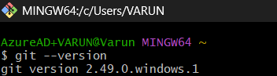

## Basic CLI Commands

### Command: pwd

**Description:** Prints the directory the user is working in.

### Command: ls

**Description:** Lists all files and directories in the current directory.



### Command: date

Description: shows the current date and time in a standard format

### Command: clear

Description: The clear command in the CLI is used to clear all the current text and output displayed in the terminal window.

### Command: time

Description: The time command in the CLI is used to measure the execution time of a command or program.

### Command: cd ‘Directory’

**Description:** Changes the current working directory to the desired directory.

### Command: cd ..

Description: Goes back to the previous directory.

### Command: mkdir

**Description:** To create a new directory.

### Command: rmdir

**Description: To delete a directory**

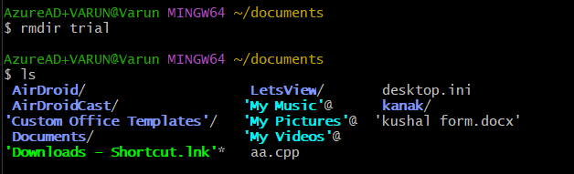

## Vim Text Editor

### Command: vi hi.txt

**Description:** Opens (or creates) the file hi.txt in the Vim text editor.

### Command: i (Insert Mode)

**Description:** Enters insert mode in Vim to allow text input.

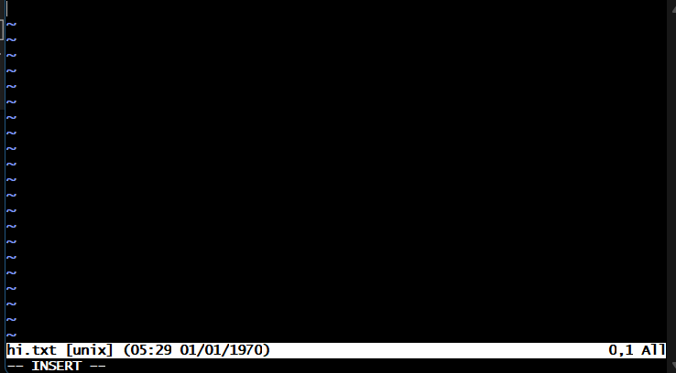

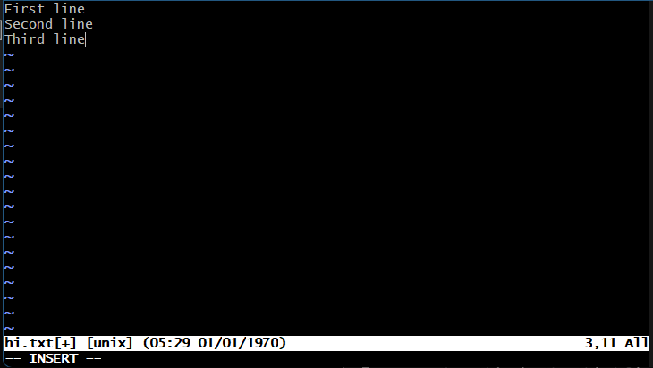

### Command: esc

Description: Used to exit insert mode

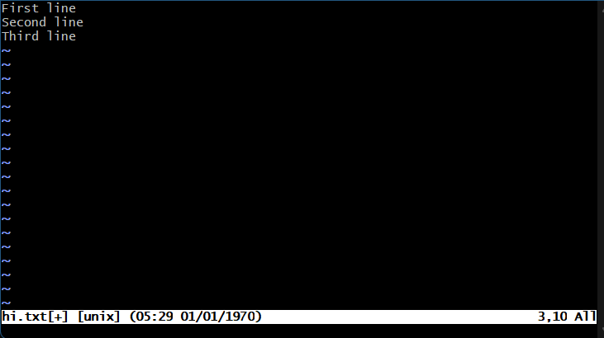

* 1. **Command: :wq**

**Description:** Saves the changes and exits the Vim editor.

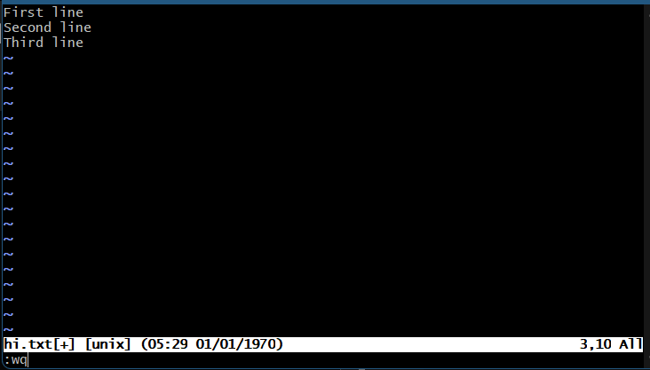

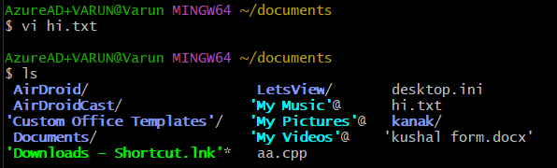

## Git Commands

### Command: git - - version

Description: The git --version command is used to check the installed version of Git on your system.

### Command: git init

**Description:** Initializes a new Git repository in the current directory.

### Command: git status

**Description:** Displays the current status of the working directory and staging area.

### Command: git add Test.c

**Description:** Add hi.txt to the staging area in preparation for a commit.

### Command: git commit -m “add file one”

**Description:** Commits the stage changes with the message “add file one”.

### Command: git log

**Description:** Display the commit history of the repository.

### Command: git clone

**Description:** To obtain a copy of an existing Git repository.

### Command: git log --oneline

**Description:** For generating shorter commit ID.

### Command: git diff

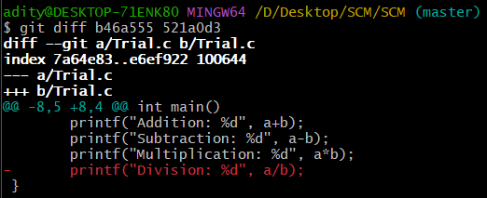**Description:** To compare two files.

+

### Command: git remote add “Variable”

**Description:** To connect with the Users GitHub account.



### Command: git remote

**Description:** To check the status of the repositories connected with the Users account.

### Command: git push -u “Variable” master

**Description:** To push all the files to the Users account.

### Command: git merge “File_Name” -m “comment”

**Description:** To merge a branch with main branch.

# SCM Project

The project is to make a repository in GitHub, make 3 branches and merge it with the main branch and access all 4 team-mate’s repositories, fork it, clone it, make some changes and merge them.

First, make your own repositories and make 3 branches and add files and merge with the main branch.

1. **Go to the directory on your computer**



1. **Git init the folder**

1. **Make three branches**





1. **Checkout to the first branch**

1. **Create a html file, add the file and commit it**

1. **Reopen the file, make changes, add the file again and commit**

1. **Checkout to the second branch, do the steps again for adding and committing a file 3 times.**

1. **Checkout to the third branch after committing 3 changes in the previous branch**

1. **Checking out to the main branch**

1. **Merging the first branch (Update_Student_Record) to the master branch**

1. **Same way merging the rest branches with the main branch as well**

1. **Using “git log –oneline” to check all the commits**



1. **Using git remote to add GitHub repository**

1. **Pushing all the commits and file in the GitHub repository**

